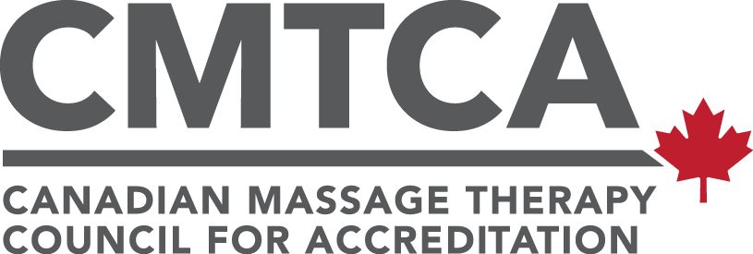

CMTCA Decision Making Framework

The CMTCA decision-making framework provides the necessary parameters to determine accreditation decisions. It is used to determine both Preliminary Accreditation results and site visit results.

The framework combines quantitative and qualitative data to reflect the full breadth and scope of a massage therapy education program. The qualitative component is gathered through the site visit, as surveyors use the tracer methodology to assess the program. The quantitative component is the summation of the ratings provided by surveyors.

Site visit accreditation decisions are in effect for five years, three years, or one year.

Preliminary Accreditation is in effect from the date of the notification letter until the date the accreditation decision is issued following the site visit. This can be anywhere between six months and two years.

The decision-making framework specifies that accreditation decisions are determined based on two factors:

- Standard 1: Given the importance of and the high impact of standard 1 on the quality of massage therapy education programs, the ratings for standard 1 are considered separately.

- Percentage of points achieved: Each rating (met, partially met, and unmet) is assigned a point value and the percentage of total possible points is calculated. The thresholds are as follows:

    - For a five-year accreditation, all criteria in standard 1 must be met AND 95% or higher of the total possible points must be obtained.

    - For a three-year accreditation, all criteria in standard 1 must be met AND between 85% and 94% of the total possible points must be obtained.

    - For a one-year accreditation, all criteria in standard 1 must be met or partially met, AND between 75% and 84% of the total possible points must be obtained.

Note: To be eligible for one, three, or five year accreditation, there cannot be any unmet criteria in standard 1.

401-240 Bank Street, Ottawa, K2P 1X4 • 416-466-3427 • info@cmtca.ca

